Exercise 1
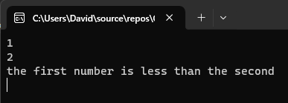
Exercise 2
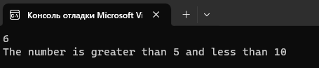
Exercise 3
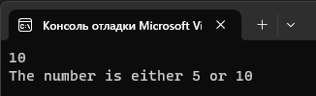
Exercise 4
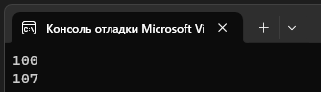
Exercise 5
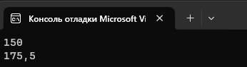
Exercise 6
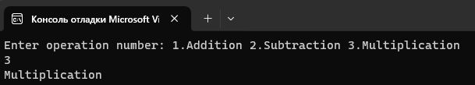
Exercise 7
